
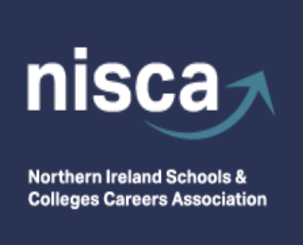
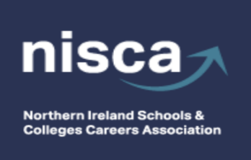

Conference Sponsor

NISCA SPRING CONFERENCE

Thursday 21st May 2026
La Mon Hotel & Country Club, Belfast

9:00 - 9:30 Registration, Tea/Coffee & Scones and visiting exhibition stands

9:30 – 9:40 Welcome to NISCA Conference
Rosie Cooper and Stephanie Murphy, NISCA Co-Chairs

09:40 - 10:20 Primary Conference Sponsor: UCAS – Keynote address
UCAS Insights: What’s changed and what you need to know
Join UCAS for this essential update packed with insights, trends, and practical guidance. Discover what’s changed, what’s ahead, and how you can best support your students with confidence and clarity.

10:20 – 11:00 Workshops - Session (1)

11:00 - 11:30 Tea/Coffee Break and visiting Exhibition stands

11:35 - 12:15 Workshops - Session (2)

12:20 – 13:00 Dundalk Institute of Technology/QUB collaboration

13:00 – 14:00 LUNCH and visiting exhibition stands

14:00 – 14:40 ‘Helping pupils get work-ready’
Led by Workplus, this session will explore what employers are looking for, the skills that
matter most in a fast-changing world, and the areas where young people can often be
underprepared. It will also provide practical ideas and actions that schools can use to
help prepare pupils for the transition into work.

14:40 - 15:20 An overview of the latest Labour Market Information, skills forecasts and a
broader economic outlook, plus the impact of AI and the NI public finances
Gareth Hetherington MBE – Director, Ulster University Economic Policy Centre.

15:20 Closing remarks



