
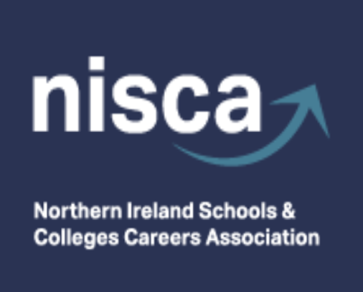
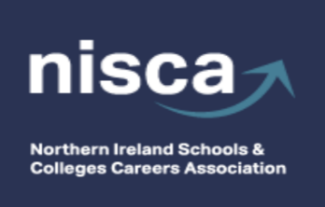

Conference Sponsor

NISCA AUTUMN CONFERENCE

Thursday 19th November 2026
La Mon Hotel & Country Club, Belfast

9:00 - 9:30 Registration, Tea/Coffee & Scones and visiting exhibition stands

9:30 – 9:40 Welcome to NISCA Conference
Rosie Cooper and Lorraine Barry, NISCA Co-Chairs.

9:40 - 10:20 Primary Conference Sponsor: Liverpool John Moores University – Keynote address

10:20 – 10:50 Building Surveying: A Career You May Not Have Considered
Joanne Wright & Trevor Hyde, Ulster University
BSc Hons Building Surveying (FT) & (PT) Course Directors & Lecturers.

10:55 – 11:35 Workshops - Session (1)

11:35 - 12:05 Tea/Coffee Break and visiting Exhibition stands

12:10 - 12:50 Workshops - Session (2)

12:55 – 13:15 Promoting awareness of Careers and opportunities in Green jobs and Green Skills
Gordon Parkes, NIE Networks Executive Director and Green Skills Steering Group Chair

13:15 – 14:15 LUNCH and visiting exhibition stands

14:20 – 14:50 Level 2 Further Education Pathways: Understanding Traineeships and Their Benefits
Tanya Heslip, Further Education Development and Quality Manager, Belfast Met.

14:50 – 15:20 Post-Primary Evaluation of CEIAG
Cathy Buhac, Education & Training Inspectorate

15:20 Closing remarks



